1. Redis is in-memory data store that is commonly used with web application.
2. In some lecture, we saw running the redis instance using docker and it seemed to be really easy and really straightforward.
3. But I want to show you kinf od oddity around using redius with docker very quickly.
4. Let’s do something with redis on our local machine without involving the docker into this.
   1. Install redis server on the machine.
   2. Then run the command 🡺 redis-server from the command problem.  
      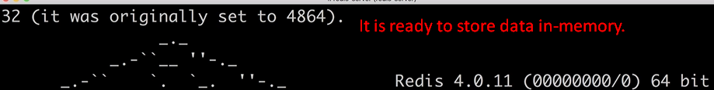
   3. Now we want to poke around into the redis server using some 2nd program called 🡺 redis CLI.  
      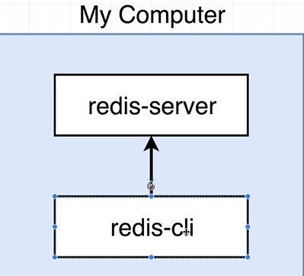  
      Let’s run the Redis CLI from some other prompt.  
      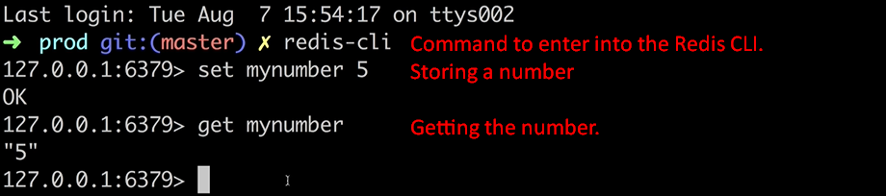
5. Above we saw how to launch redis CLI from outside docker (means without using docker).
6. Let’s try starting up redis using docker and then you’re going to very quickly see some interesting behavior around redis.
7. Below lunching redis server via docker.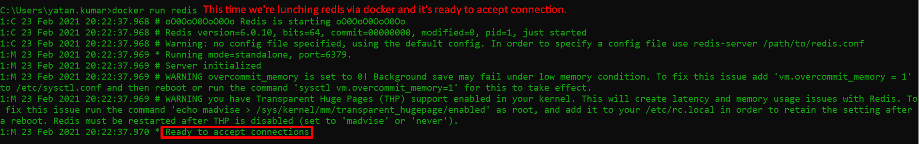
8. Lunching **redis CLI**.  
   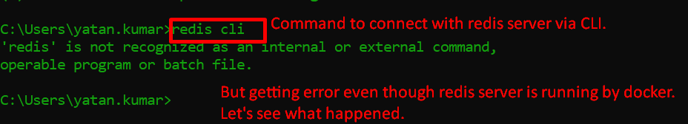
9. 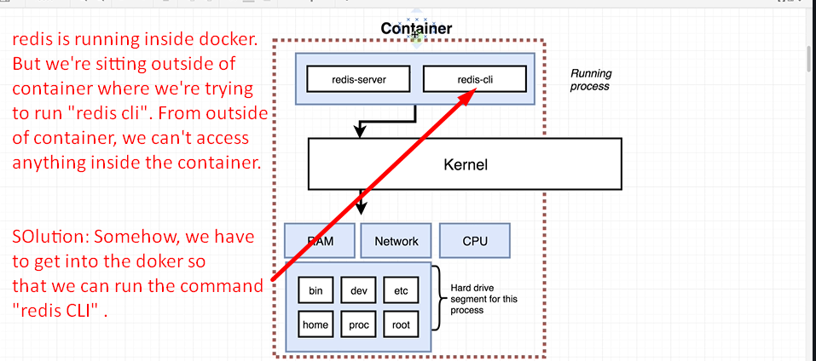
10. We will see in the next section how to execute a second command inside of a running container.